Help Improve Health Care for Teens!

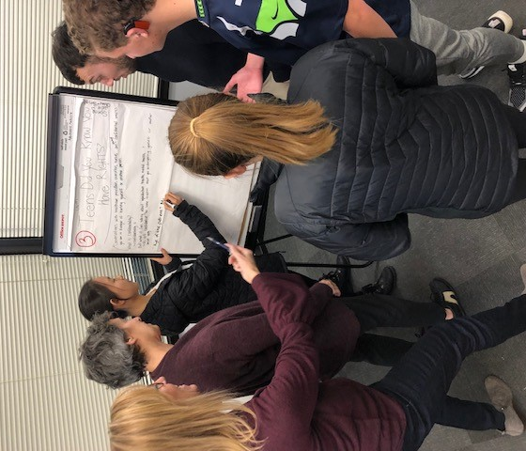
Make an impact on healthcare!
It’s not just us and them!
Have your voice heard!
Meet parents with teens at other high schools!
Collaborate with healthcare providers and teens!

Join the UW LEAH Parent Advisory Board
The UW LEAH (LEAH = Leadership Education in Adolescent Health) Parent Advisory Board will share their perspectives and advise adolescent healthcare providers across multiple fields including medicine, nursing, nutrition, psychology and social work.
Our first meeting is 6PM on Monday, February 3, 2020
at Seattle Children’s

If you are interested, please complete an application on our website by 6PM January 8, 2020!
Meet monthly at Seattle Children's Hospital to:
- Collaborate with healthcare providers and teens
- Educate health providers about the parent experience
- Create and develop projects related to improving teen healthcare
- Discuss topics such as:
  - Mental health and stress
  - Substance use and abuse
  - Healthy lifestyles
  - Sexual and reproductive health
  - Confidentiality and teen rights

UW LEAH
LEADERSHIP EDUCATION in
ADOLESCENT HEALTH

